Mohamed Zouheir

Project 2 Group 10

Term 2 Individual Submission

ERD diagram

All members of the group are responsible for the Event table. I am responsible for the Booking table. The Booking table I am responsible for is highlighted.

Booking Table

The booking table is responsible for storing the details related to tickets. The booking table has 5 attributes. Ticket number, attdNumber, Time, Date, EventID and AttdType. The ticket number identifies the ticket and is the primary key. The attdNumber identifies the who booked the ticket and is a foreign key from either lecturer or student. Time and Date is when the booked event will take place. EventID identifies the event and is a foreign key from Event table. The AttdType identifies if the attendee is a student or lecturer.

|  |  |  |  |  |  |
| --- | --- | --- | --- | --- | --- |
| Ticket_Number | attdNumber | Time | EventID | AttdType | Date |
| 69385623 | 22122619 | 15:00:00 | 9ETPABAE | S | "2023-06-30" |
| 58404113 | 21688106 | 15:00:00 | M4Z3ZLKQ | S | "2023-07-24" |
| 69509310 | 22070480 | 16:00:00 | EO75CAIN | S | "2023-08-12" |
| 39462981 | 22154842 | 15:00:00 | NL2DZH4I | L | "2023-09-11" |
| 92558449 | 22023748 | 16:00:00 | PS4EL6KB | S | "2023-08-16" |
| 60939399 | 21916609 | 18:00:00 | D0KEY9UP | S | "2023-07-23" |
| 30897334 | 22052177 | 15:00:00 | P13KM4EX | S | "2023-06-25" |
| 97448381 | 22215126 | 9:00:00 | YNGJTLLB | L | "2023-11-01" |
| 65494103 | 21967820 | 15:00:00 | LPDZAYUU | S | "2023-08-15" |
| 15343903 | 22187530 | 15:00:00 | RO9ZW3S4 | L | "2023-10-16" |
|  |  |  |  |  |  |

Attributes

* Ticket Number: Integer
* attdNumber: Integer
* Time: time
* EventID: String(8)
* AttdType: Char
* Date: date

Event Table

The Events table is in charge of recording all relevant information about a created event, such as the type of event, the host, the name of the event, its description, time, date, location, approval status, and price.

|  |  |  |  |  |  |  |  |  |  |
| --- | --- | --- | --- | --- | --- | --- | --- | --- | --- |
| EventID | EventType | leader | title | Time | Location | isApprovedBy | ApprovalStatus | Date | Description |
| 9ETPABAE | Sports | 21688106 | Soccer Tournament | 15:00:00 | BSPSOA | 21589254 | TRUE | "2023-06-30" | An informal fast paced soccer tournament |
| M4Z3ZLKQ | Education | 22070480 | Study Advice for 1st year and beyond | 15:00:00 | LEC119 | 21440431 | TRUE | "2023-07-24" | A guide for new students on how to approach studies |
| EO75CAIN | Arts & Culture | 22154842 | Musician workshop | 16:00:00 | CPTHAL | 21021026 | TRUE | "2023-08-12" | A workshop for attendees to gain knowledge on music theory and DAW software |
| NL2DZH4I | Social | 22023748 | 1st year meet & greet | 15:00:00 | AMPCPT | 21606653 | FALSE | "2023-09-11" | We welcome all 1st years to attend to make connections and meet your fellow students |
| PS4EL6KB | Education | 21916609 | Information Literacy workshop | 16:00:00 | LEC119 | 21392393 | FALSE | "2023-08-16" | A crash course on referencing, source accreditation and applying findings from sources |
| D0KEY9UP | Social | 22052177 | Game night | 18:00:00 | CPTHAL | 21519198 | TRUE | "2023-07-23" | Feel free bring a board game or cards and enjoy a night of gaming |
| P13KM4EX | Education | 22215126 | Applying Object Oriented principles in software | 15:00:00 | LEC119 | 21073413 | TRUE | "2023-06-25" | OOP can be difficult to wrap your head around, with this workshop we hope to leave you with a solid understanding of OOP |
| YNGJTLLB | Arts & Culture | 21967820 | International cuisine festival | 9:00:00 | AMPCPT | 21812659 | FALSE | "2023-11-01" | Taste the world one stall at a time, come and enjoy the food prepared from our students from around the world |
| LPDZAYUU | Sports | 22187530 | Rugby Tournament | 15:00:00 | BSPRUB | 21448733 | TRUE | "2023-08-15" | A day long informal rugby tournament |
| RO9ZW3S4 | Sports | 22122619 | Yoga classes | 15:00:00 | BSPRUB | 21810373 | FALSE | "2023-10-16" | A beginner friendly yoga class |

Attributes

|  |  |  |  |  |  |  |  |  |  |
| --- | --- | --- | --- | --- | --- | --- | --- | --- | --- |
| EventID | EventType | leader | title | Time | Location | isApprovedBy | ApprovalStatus | Date | Description |

* EventID-String(8)
* EventType-String(40)
* Leader-Integer
* Title-String(40)
* Time-time
* Location-String(6)
* isApprovedBy-Integer
* ApprovalStatus-Boolean
* Date-date
* Description-String(40)

User Interface

Booking table

Within the user interface the booking table will be utilized when users decide to attend events or view events they are currently booked for. When users press the attend button their relevant details must be added to the bookings table and when a user wishes to view events for which they are currently booked the bookings table must be queried.

Students Live Events Screen

* This page allows students to see live approved events and book tickets for them
* When users press attend their details must fetched from the application and then be saved to the booking table

Student My Events Screen

* Here students are able to create events and view events they have booked or created
* For viewers to see the events they’ve booked the booking table must be queried and results displayed in the applications user interface

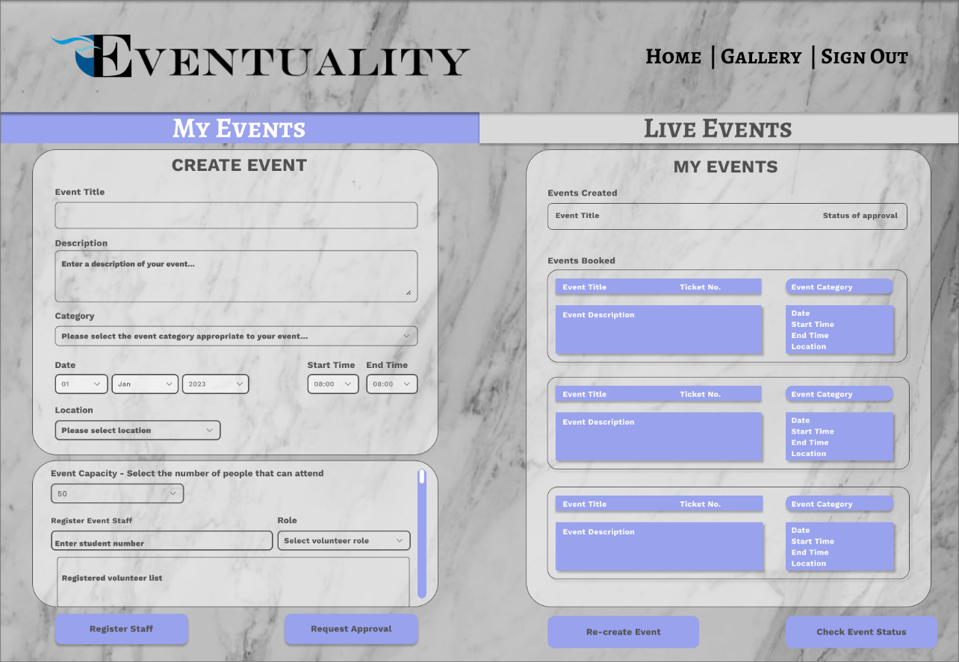

Business Rules

1. New users must register.

2. They can only register if they have a student/staff number.

3. A student can become a volunteer.

4. An event can have multiple volunteers.

5. A Student can be a volunteer for multiple events

6. A student can be the leader to one active event at a time

7. A Student/Lecturer can book attendance to an live/approved event.

8. An event can have multiple bookings.

9. A Student/Lecture can only book one ticket to an event.

10. They can book to multiple events

11. A lecturer can approve or deny multiple events.

12. If event is denied student can create a new event.

13. A student can edit the event if its pending.

14. They cannot edit if its approved,

15. An event can only be one type, many events can be the same type.

16. An event must be held at a location.

17. Only one location can have an event at a time.

18. Students/lecturer can request password change if forgotten.

19. Students are not charged for booking.

20. Booking must be made 7 days before event occurs.

Reflection

Time management skills were essential for this project. I had to learn how to organize my workload, establish reasonable timeframes, and breakdown problems. I can still improve in these areas. The situation on campus has taught me to be more prepared for projects as events may occur which suddenly disrupt your ability to work.

This project has made me think a lot about the task of designing good databases. Many concepts we learned in class are now being applied in this project. I’ve come to appreciate people who design databases as it becomes increasingly more complicated the more data you work with. I now realize that I must cultivate the necessary skills by practicing normalization and familiarizing myself with SQL. This phase of the project has given me a set of skills that I can work on to improve my database design.